The Charts Include Everything

I ran all algorithms on all problems overnight (actually took like three hours) and used `> out.txt` to direct all the output to a file. Then I read that file in with a Python script to generate a .csv that looks like this:

I read that back in to a different script as a pandas Dataframe to make plots. So all my plots contain data from all possible experiments.
Number of Expansions vs Number of Actions

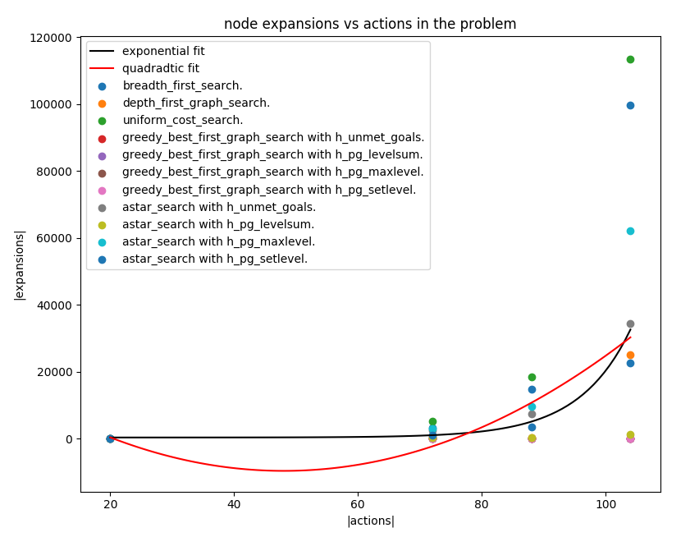
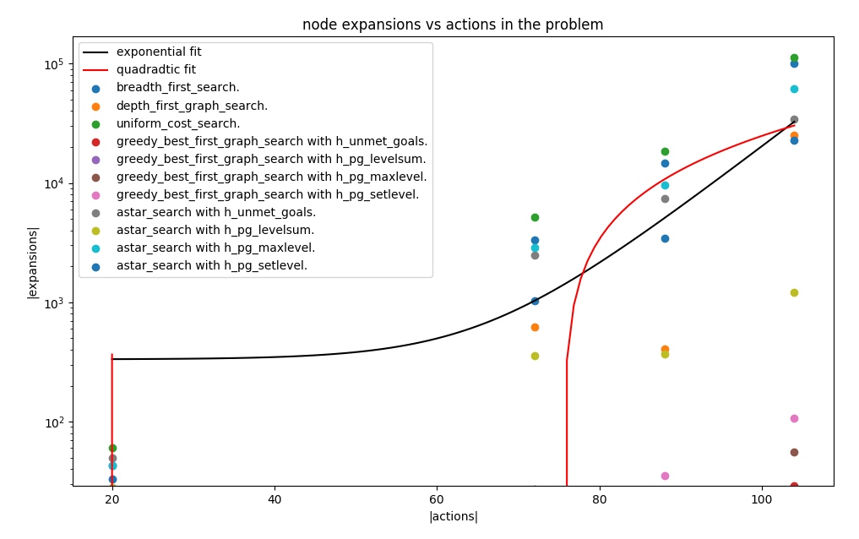
(linear and then logspace. Sorry if you’re colorblind.)

I’ve tried to fit the data to a polynomial (quadratic shown), but no polynomial of any order captures the data well, as is especially apparent in logspace. An exponential curve is much better, which matches the fact the search spaces grow exponentially with problem complexity.

Breadth-first search and Uniform-cost search seem to make the most expansions.

Search Time vs Number of Actions

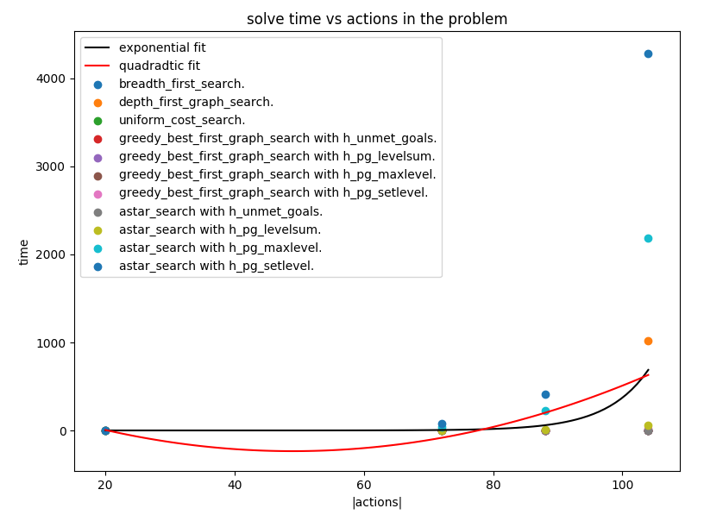
Again it grows exponentially.

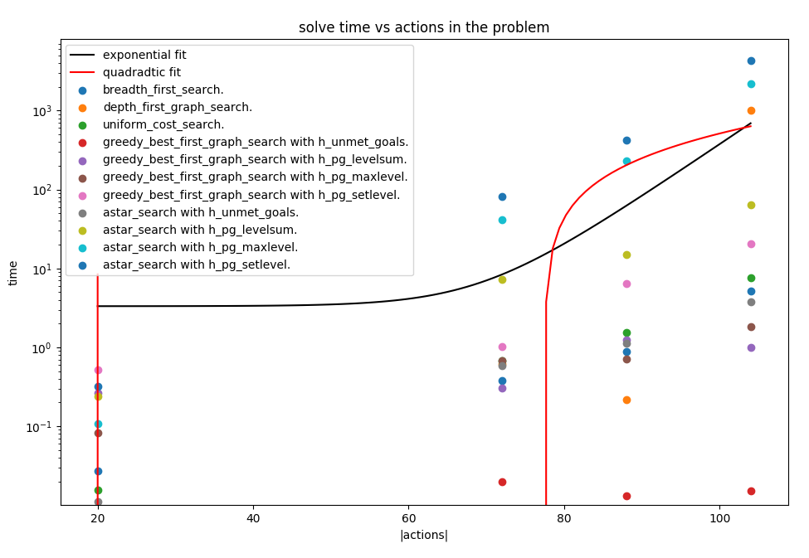
And here it is in logspace.

Greedy best-first with the unmet goals heuristic seems to be reliably fastest. That doesn’t mean the solution it finds is optimal, just that it finds a candidate without doing too much work.

Again, time spent tends to grow exponentially, because the search space itself grows exponentially. This doesn’t fit a polynomial.

Solution Lengths
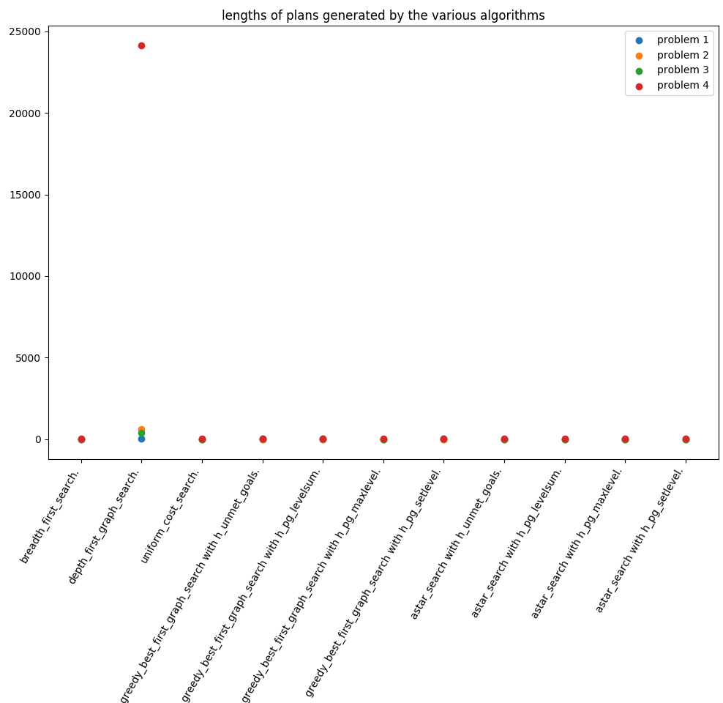
Linear space

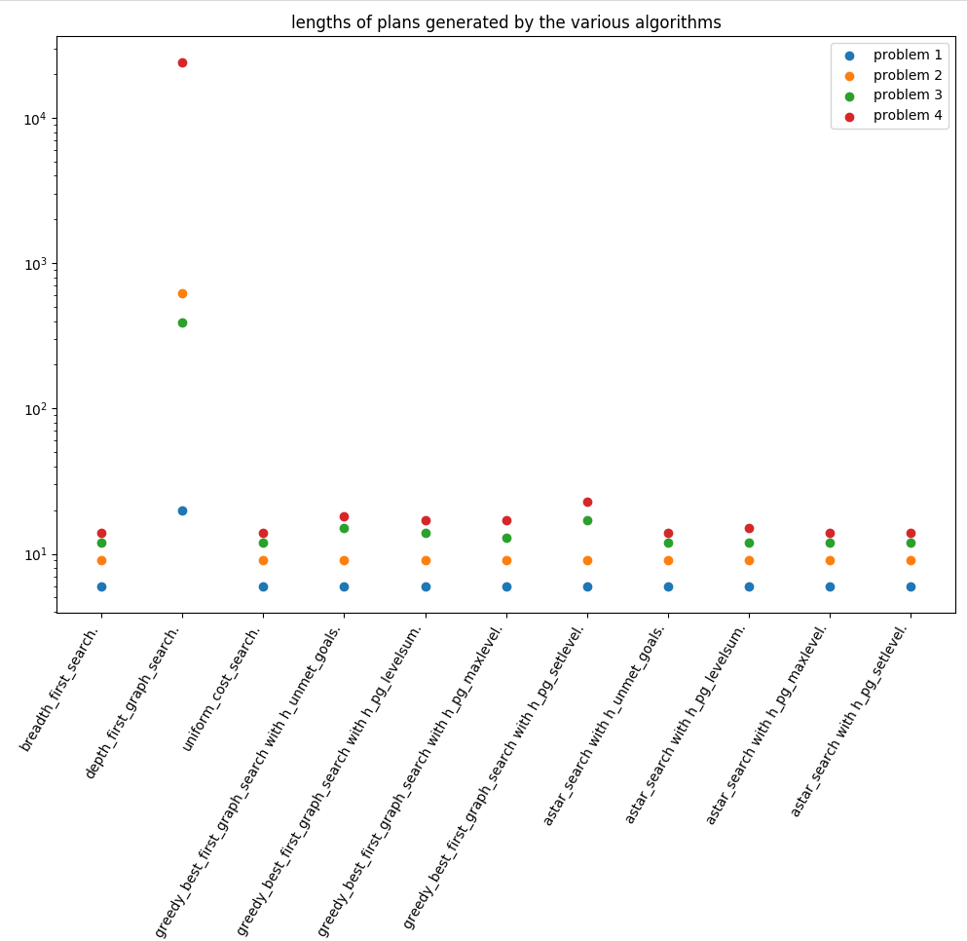
Logspace

So clearly depth-first search is the loser. No surprises there. It doesn’t back up when it does something wrong or unproductive, so it has to stumble its way to the goal, all the while getting in its own way.

Also no surprise, breadth-first search always finds the shortest plan, just like it always finds the shortest path through a graph.

Questions

1. Real time operation in a small search space

I’d favor Greedy Best-First with the Unmet Goals heuristic, because it dominates the others on timeliness and space-efficiency and seems to return optimal plans (as good as any of the other approaches) so long as the search space is small. (And it doesn’t do much worse than optimal even for slightly larger spaces.)

2. Large domains

In incredibly large domains, time and space are going to matter most. Greedy Best-First with Unmet Goals heuristic is fast and small. So is Greedy Best-First with Level Sum heuristic and Greedy Best-First with Max Level heuristic. A* with Unmet Goals heuristic is also very fast and might give a slightly more optimal answer, if you can spare the memory for all the expansions.

3. When optimality matters most

If actions are pretty expensive, like actually flying a plane from one place to another, then you really want to make sure the plan is optimal. From Robotics: Thinking is cheaper than communicating; communicating is cheaper than moving. BFS, Uniform Cost Search, and any of the A* with an admissible heuristic (not levelsum) will achieve shortest plan. In these experiments BFS seems to dominate time-wise—at least for this implementation of A* and heuristics—, so if you’re in a hurry and don’t care about expanding more nodes and all actions happen to have the same cost, BFS. If you care about minimizing the number of nodes explored, which in an optimized implementation probably corresponds better with time, use A* with something like the set-level heuristic. If the cost of achieving a literal is actually more complicated than just its level in a planning graph, then definitely A* with a heuristic that encodes that complication.

